



**SMART CAR PARKING SYSTEM**

BEC

##### A MINOR PROJECT- I REPORT

###### ***Submitted by***

###### 

##### MANOJ M T (927622BEC114)

**BACHELOR OF ENGINEERING**

in

**DEPARTMENT OF ELECTRONICS AND COMMUNICATION ENGINEERING**

**M.KUMARASAMY COLLEGE OF ENGINEERING**

(Autonomous)

**KARUR – 639 113**

**DECEMBER 2023**

**M.KUMARASAMY COLLEGE OF ENGINEERING, KARUR**

**BONAFIDE CERTIFICATE**

Certified that this **18ECP103-Minor Project I** report “SMART CAR PARKING SYSTEM**”** is the bonafide work M.T.MANOJ (927622BEC114) who carried out the project work under my supervision in the academic year 2023-2024-ODD

|  |  |
| --- | --- |
| SIGNATURE  Dr.A.KAVITHA B.E., M.E., Ph.D.,  HEAD OF THE DEPARTMENT**,**  Professor,  Department of Electronics and  Communication Engineering, Communication Engineering,  M.Kumarasamy College of Engineering, M.Kumarasamy College of Engineering, Thalavapalayam, Thalavapalayam,  Karur-639113. Karur-639113. | SIGNATURE  SUPERVISOR,  Dr.G.Shanmugavadivel  SUPERVISOR,  Assistant Professor,  Department of Electronics and Communication Engineering,  M.Kumarasamy College of Engineering, M.Kumarasamy College of Engineering, Thalavapalayam, Thalavapalayam,  Karur-639113. |

This report has been submitted for the **18ECP103L – Minor Project-II** final review held at M. Kumarasamy College of Engineering, Karur on

**PROJECT COORDINATOR**

**INSTITUTION VISION AND MISSION**

**Vision**

To emerge as a leader among the top institutions in the field of technical education.

**Mission**

**M1:** Produce smart technocrats with empirical knowledge who can surmount the global challenges.

**M2:** Create a diverse, fully -engaged, learner -centric campus environment to provide quality education to the students.

**M3:** Maintain mutually beneficial partnerships with our alumni, industry and professional associations

**DEPARTMENT VISION, MISSION, PEO, PO AND PSO**

**Vision**

To empower the Electronics and Communication Engineering students with emerging technologies, professionalism, innovative research and social responsibility.

**Mission**

**M1:** Attain the academic excellence through innovative teaching learning process, research areas & laboratories and Consultancy projects.

**M2:** Inculcate the students in problem solving and lifelong learning ability.

**M3:** Provide entrepreneurial skills and leadership qualities.

**M4:** Render the technical knowledge and skills of faculty members.

**Program Educational Objectives**

**PEO1:** **Core Competence:** Graduates will have a successful career in academia or industry associated with Electronics and Communication Engineering

**PEO2:** **Professionalism:** Graduates will provide feasible solutions for the challenging problems through comprehensive research and innovation in the allied areas of Electronics and Communication Engineering.

**PEO3:** **Lifelong Learning:** Graduates will contribute to the social needs through lifelong learning, practicing professional ethics and leadership quality

**Program Outcomes**

**PO 1: Engineering knowledge:** Apply the knowledge of mathematics, science, engineering fundamentals, and an engineering specialization to the solution of complex engineering problems.

**PO 2: Problem analysis:** Identify, formulate, review research literature, and analyze complex engineering problems reaching substantiated conclusions using first principles of mathematics, natural sciences, and engineering sciences.

**PO 3: Design/development of solutions:** Design solutions for complex engineering problems and design system components or processes that meet the specified needs with appropriate consideration for the public health and safety, and the cultural, societal, and environmental considerations.

**PO 4: Conduct investigations of complex problems:** Use research-based knowledge and research methods including design of experiments, analysis and interpretation of data, and synthesis of the information to provide valid conclusions.

**PO 5: Modern tool usage:** Create, select, and apply appropriate techniques, resources, and modern engineering and IT tools including prediction and modeling to complex engineering activities with an understanding of the limitations.

**PO 6: The engineer and society:** Apply reasoning informed by the contextual knowledge to assess societal, health, safety, legal and cultural issues and the consequent responsibilities relevant to the professional engineering practice.

**PO 7: Environment and sustainability:** Understand the impact of the professional engineering solutions in societal and environmental contexts, and demonstrate the knowledge of, and need for sustainable development.

**PO 8: Ethics:** Apply ethical principles and commit to professional ethics and responsibilities and norms of the engineering practice.

**PO 9: Individual and team work:** Function effectively as an individual, and as a member or leader in diverse teams, and in multidisciplinary settings.

**PO 10: Communication:** Communicate effectively on complex engineering activities with the engineering community and with society at large, such as, being able to comprehend and write effective reports and design documentation, make effective presentations, and give and receive clear instructions.

**PO 11: Project management and finance:** Demonstrate knowledge and understanding of the engineering and management principles and apply these to one’s own work, as a member and leader in a team, to manage projects and in multidisciplinary environments.

**PO 12: Life-long learning:** Recognize the need for, and have the preparation and ability to engage in independent and life-long learning in the broadest context of technological change.

**Program Specific Outcomes**

**PSO1:** Applying knowledge in various areas, like Electronics, Communications, Signal processing, VLSI, Embedded systems etc., in the design and implementation of Engineering application.

**PSO2:** Able to solve complex problems in Electronics and Communication Engineering with analytical and managerial skills either independently or in team using latest hardware and software tools to fulfil the industrial expectations.

|  |  |
| --- | --- |
| **Abstract** | **Matching with POs,PSOs** |
| **LCD IR AU DC** | **PO1, PO2, PO3, PO4, PO5, PO6,PO7, PO8, PO9, PO10, PO11, PO12, PSO1, PSO2** |

**ACKNOWLEDGEMENT**

Our sincere thanks to Thiru.M.Kumarasamy, Chairman and Dr.K.Ramakrishnan, Secretary of M.Kumarasamy College of Engineering for providing extraordinary infrastructure, which helped us to complete this project in time.

It is a great privilege for us to express our gratitude to Dr.B.S.Murugan., B.Tech., M.Tech., Ph.D., Principal for providing us right ambiance to carry out ;this project work.

We would like to thank Dr.A.Kavitha, Professor and Head, Department of Electronics and Communication Engineering for his unwavering moral support and constant encouragement towards the completion of this project work.

We offer our wholehearted thanks to our Project Supervisor, Dr.G.Shanmugavadivel

Assistant Professor Department of Electronics and Communication Engineering for his precious guidance, tremendous supervision, kind cooperation, valuable suggestions, and support rendered in making our project successful.

We would like to thank our Minor Project Co-ordinator, Dr.K.Sivanandam, M.E., Ph.D., Associate Professor, Department of Electronics and Communication Engineering for his kind cooperation and culminating in the successful completion of this project work. We are glad to thank all the Faculty Members of the Department of Electronics and Communication Engineering for extending a warm helping hand and valuable suggestions throughout the project. Words are boundless to thank our Parents and Friends for their motivation to complete this project successfully

ABSTRACT

The main objective of this project is to reduce the traffic congestion in roads, multi-storeyed buildings and malls due to unavailability of parking spaces .The project displays the nearest empty slot if present with respect to user location. Our project aims to make efficient use of parking spaces. We track vacant slots in the parking space and assign that to the user. Smart parking system as described above can lead to an error-free reliable, secure and fast management system. In recent times the concept of smart cities have gained great popularity. Consistent efforts are being made in the field of IoT in order to maximize the productivity and reliability of urban infrastructure. Problems such as, traffic congestion, limited car parking facilities and road safety are being addressed by IoT. The proposed Smart Parking system consists of an on-site deployment of an IoT module that is used to monitor and signalize the state of availability of each single parking space. A mobile application is also provided that allows an end user to check the availability of parking space and book a parking slot accordingly. The paper also describes a high level view of the system architecture. Towards the end, the project discusses the working of the system in form of a use case that proves the correctness of the proposed model.

TABLE OF CONTENTS

CHAPTERCONTENTSPAGE

Institution vision and Mission iii

Department Vision and Mission iii

Department PEOs, Pos and PSOs iv

Abstract viii

List of Tables xi

List of Figures xii

List of Abbreviations xiii

1 INTRODUCTION

1.1 Relevance of the project 12

1.2 Problem Statement 13

1.3 Enhanced user Experience 13

2 LITERATURE SURVEY

2.1 Technical and research papers 16

3 SYSTEM REQUIREMENTS SPECIFICATION 18

3.1 Functional Requirements 18

3.2 Non functional Requirements 19

4 SYSTEM ANALYSIS AND DESIGN 20

4.1 Node Mcu 20

4.2 16*2 LCD Display 21

* 1. IR Sensors 22

TABLE OF CONTENTS CONTENTS PAGE NO

CHAPTER NO

5 IMPLEMENTATION 23

5.1 Network Time Protocol 23

5.2 Parking a Vehicle 24

6 RESULTS AND DISCUSSION 25

6.1 Initial Setup 25

6.2 Parking a vehicle 26

6.3 No available parking slots 26

7 7.1 CONCLUSION 27

7.2 Future work 27

**LIST OF ABBREVIATIONS**

|  |  |  |
| --- | --- | --- |
| **ACRONYM** |  | **ABBREVIATION** |
| LCD | - | Liquid Crystal Display |
| IR | - | Infrared Sensor |
| AU | - | Arduino Uno |
| DC | - | DC servo Motor |

CHAPTER 1  
1.1 INTRODUCTION

The project entitled smart parking system is to manage all the parking facilities to an user. The recent growth in economy and due to the availability of low price cars in the market, an every average middle-class individual can afford a car, which is good thing, however the consequences of heavy traffic jams, pollution, less availability of roads and spot to drive the motor car. One of the important concerns, which is to be taken in accounting, is the problem of parking those vehicles . Though, if there is space for parking the vehicle but so much time is squandered in finding that exact parking slot resulting in more fuel intake and not also environment friendly. It will be a great deal if in some way we find out that the parking itself can provide the precise vacant position of a parking slot then it'll be helpful not limited to the drivers also for the environment . Initially when the user is about to enter the location the LCD displays the number of empty and filled spots and when the user is with its vehicle near to the parking detect sensor ,he/she would be thrown with a notification on their mobile app of the parking slot number ,where they should park there vehicle

1.1 Relevance of the project

The main important benefit of a smart parking system is its advanced technology. It follows the latest technologies and concepts to assure profitable out comes . The design and implementation of smart parking is very easy to supervise and manage. This system can be easily handled by the staff members because of its well organized structure

1.2 Problem Statement

In recent research in metropolitan cities the parking management problem can be viewed from various angles such as high vehicle density on roads. This results in annoying issues for the drivers to park their vehicles as it is very difficult to find a parking slot. The drivers usually waste time and effort in finding parking space and end up parking their vehicles finding a space on the street which further leads to space congestion. In worst case, people fail to find any parking space especially during peak hours and festive season.

1.3 Objective

Smart Parking involves the use of low cost sensors, real-time data and applications that allow users to monitor available and unavailable parking spots. The goal is to automate and decrease time spent manually searching for the optimal parking floor, spot and even lot. Some solutions will encompass a complete suite of services such as online payments, parking time notifications and even car searching functionalities for very large lots. A parking solution can greatly benefit both the user and the lot owner.

Optimized parking – Users find the best spot available, saving time, resources and effort. The parking lot fills up efficiently and space can be utilized properly by commercial and corporate entities.

Reduced traffic – Traffic flow increases as fewer cars are required to drive around in search of an open parking space. Increased Safety – Parking lot employees and security guards contain real-time lot data that can help prevent parking violations and suspicious activity. License plate recognition cameras can gather pertinent footage. Also, decreased spot-searching traffic on the streets can reduce accidents caused by the distraction of searching for parking.

Enhanced User Experience – A smart parking solution will integrate the entire user experience into a unified action. Driver’s payment, spot identification, location search and time notifications all seamlessly become part of the destination arrival process.

Scope of the project at present some countries have portals which users can gain information about parking areas via the internet. This system can give users the information about parking space, but it won’t be able to give which parking slot is vacant and occupied.. This system cannot be installed by medium scale shopping malls, movie theatres as it can cost them a huge amount. At many public places, the system only shows the availability but it cannot show the exact slot and path to the slot available. Hence, there is the need to smartly find the path to the vacant spot.

CHAPTER 2

2.1 LITERATURE SURVEY

Ahmed Shah(2021) developed a Smart Parking Management System Using the Internet of Things Searching for parking wastes significant amounts of time and effort and leads to substantial financial costs. This is particularly the case for people who are always pressured to be on time. Smart cities employ all kinds of modern technologies to manage and enhance resources effectively. Urban parking facilities are one of the essential assets that must be managed. We developed a smart parking management system (SPMS) as a modern solution to manage parking In the context of today’s modern life, it has become necessary to improve search methods for available parking and minimize the congestion that occurs at the parking entrance. Our smart parking management system was developed to Manage parking and solve problems efficiently using technology Apply technical solutions to improve the smart cities concept The proposed system uses a variety of technologies that help manage parking. It provides essential services for users, including searching for parking, reservations and payment. An IoT-based E-Parking System for Smart CitiesThe huge proliferation in the number of vehicles on the road along with mismanagement of the available parking space has created parking related problems as well as increased the traffic congestion in urban areas. Thus, it is required to develop an automated smart parking management system that would not only help a driver to locate a suitable parking space for his/her vehicle, but also it would reduce fuel consumption as well as air pollution. It has been found that a drivers search for a suitable parking facility takes almost 15 minutes which increases the fuel consumption by the vehicle, traffic congestion and air pollution.

2.1 SMART PARKING SYSTEM TO REDUCE TRAFFIC CONGESTION

Transportation is the key-success for any of the country. Now a day, many people have options to use their own vehicle for travelling. This will surely increase the demand in trading but one of the problems created by road traffic is "parking".

To park all these vehicles in the major metro cities is quite tedious and difficult task and it became problematic to park vehicles. Lot of research and development is being done all over the world to implement better and smarter parking management mechanisms. The current smart parking systems or Wireless Sensors Network Parking requires the combination of wireless sensor networks module, Embedded web-server, Central WebServer.Sensor networks make use of Infrared (IR) Sensor nodes to check the parking slot state and send this information to embedded web-server. It thereby displays the information on a LED screen with which the user can check for empty vehicle slots. These systems not guide the users to reach to the parking lot. If the slot is not available at that time than drivers will start searching for another parking zone so that this process is time consuming and will increase the traffic congestion. This paper proposes a Reservation-based Smart Parking System for avoiding the traffic problems that provides the pre- booking of slots through the use of the mobile.

2.2 Application

Application must be installed in the user's mobile. Unlike the existing system, our idea is to use client-server architecture where client request for the reservation of slots and server responds with the slots which are available at that time. Our system is that the user has an option to go for the parking area according to his/her convenience. The advantage of this will greatly reduce the time taken by the vehicle to search for a parking area. Advanced payment modules are also included like e- wallet, debit card, credit card from which the user can pay. Penalty will be added on late exit as well as an over use of the slot after user specified entry and exit time .The refund will be given on cancelation of parking slot and early exit. The supervisor is required to monitor the area. Many of the vehicles parking facilities are unable to cope with the influx of vehicles on roads and parking area. The current smart parking systems or Wireless Sensors Network Parking requires the combination of wireless sensor networks module, Embedded web-server, Central Web-Server. Sensor networks make use of Infrared (IR) Sensor nodes to check the parking slot state and send this information to embedded web-server. It thereby displays the information on a LED screen with which the user can check for empty vehicle slots . But to use this system, additional hardware needs to be installed in the car which is not feasible . Finding a parking slot in a congested city is very hard. In many cases people go to a parking station and they find it full and there is no space available for parking. Then in search of parking space they have to again roam with their vehicle to find available parking.

Normal Parking

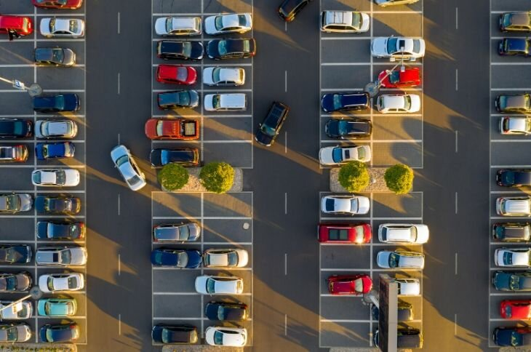

Fig 2.1

CHAPTER 3

SYSTEM REQUIREMENTS SPECIFICATION

Functional Requirement defines a function of a software system and how the system must behave when presented with specific inputs/or conditions. These may include calculations, data manipulation and processing and other specific functionality.

3.1 Functional Requirement

• The application should not display in-appropriate message for valid conditions.

• The application must not stop working when kept running for even a long time.

• The application should process information for any kind of input case.

• The application should generate the output for a given input test case

3.2 Non-Functional Requirement

Non-functional requirements are the requirements which are not directly concerned with the specific function delivered by the system. They specify the criteria that can be used to judge the operation of a system rather than specific behaviours.

3.2 System Requirements Specifications

Given below are the non-functional requirements:

• Product requirements

• Organizational requirements

• Basic operational requirements

3.3 Hardware Specifications

• ENODE MCU (ESP8266)

• JUMPER WIRES

• INFRARED SENSORS

• 16*2 LED DISPLAY

• DC MOTOR

CHAPTER 4

SYSTEM ANALYSIS AND DESIGN

4.1 Node Mcu

The Node MCU as shown in Fig 4.1has assimilated TCP/IP protocol that can give any microcontroller entrance to the Wi-Fi network that supports 2.4 GHz Wi-Fi (802.11 Wi-Fi standards)

Node MCU is capable of either connecting to an existing wireless connection or hosting an application over http protocol. Each Node MCU module comes pre-programmed with an AT command set firmware which means one can simply link this up to your Raspberry Pi device and get about like Wi-Fi shield.

The reason why we use node mcu is that it is more cost-efficient with respect to Arduino uno , in Arduino we have to use ethernet shield which provides us secure ethernet connectivity whereas all these features are provided by node mcu and it also comes with a updated feature of wi-fi , where you can power or connect your system by WiFi

Node Mcu

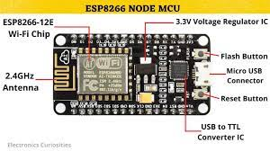

Fig 4.1

4.2LCD Display

An LCD is an electronic display module which uses liquid crystal to produce a visible image. The 16×2 LCD display is a very basic module commonly used in DIY’s and circuits. The 16×2 translates o a display 16 characters per line in 2 such lines. In this LCD each character is displayed in a 5×7 pixel matrix. The 16*2 display is used to display the number of vacant and spilled spot . It also gets updated on the display LCD when a vehicle parks or unparks the vehicle

LCD Display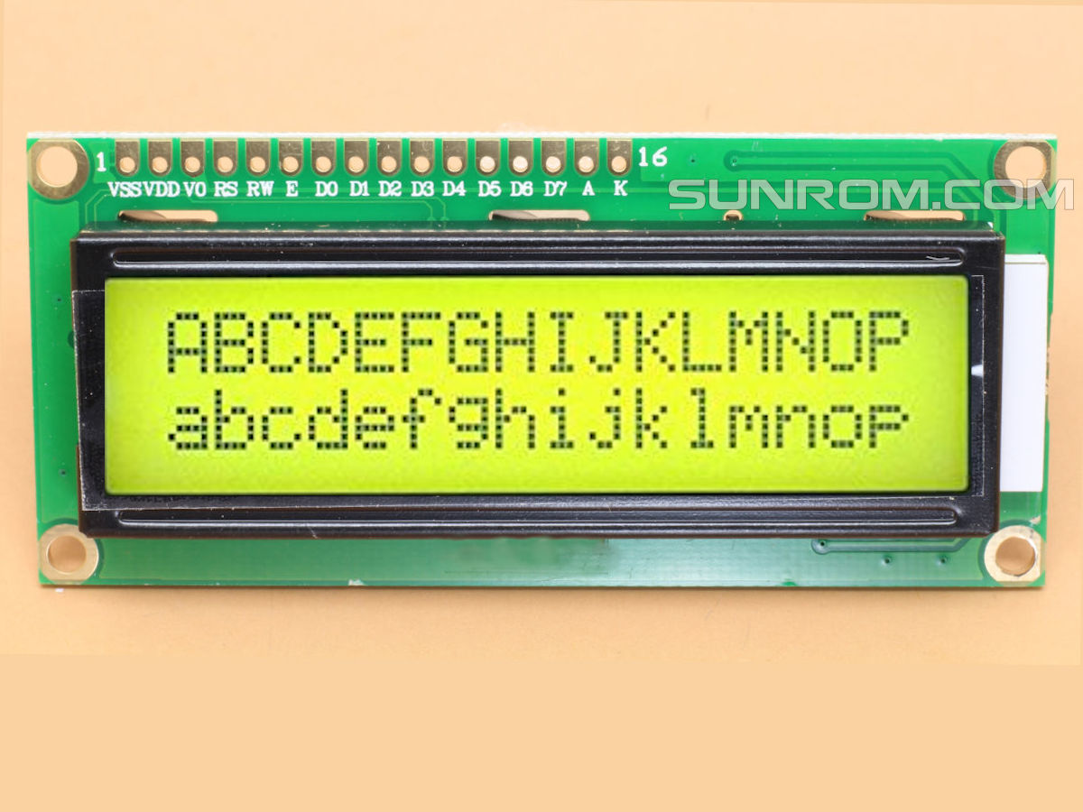

Fig 4.2

4.3 IR sensor

An infrared (IR) sensor is an electronic device that measures and detects infrared radiation in its surrounding environment. Infrared radiation was accidentally discovered by an astronomer named William Herchel in 1800. While measuring the temperature of each color of light (separated by a prism), he noticed that the temperature just beyond the red light was highest. IR is invisible to the human eye, as its wavelength is longer than that of visible light Anything that emits heat gives off infrared radiation. We are using three IR detect sensor in our project , one IR detect sensor is used to sense the vehicle near the parking sensor and other two IR detect sensor is used to send data to the node mcu which is the brain of our system whether a vehicle is parked in that slot or is unparked .

IR Sensor

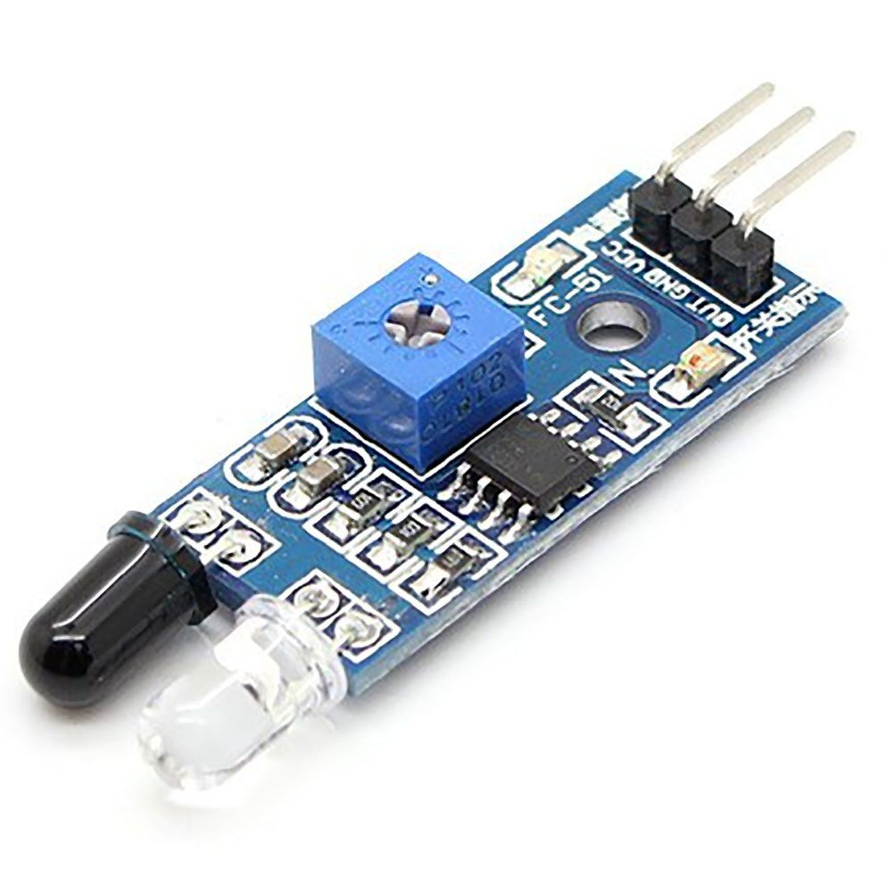

Fig 4.3

CHAPTER 5

5.1 Network Time Protocol

The Network Time Protocol is a networking protocol for clock synchronization between computer systems over packet-switched, variable-latency data networks. We have used NTP for fetching time from the NTP server so that we can show the start time and end time for the user when he parks or unparks his vehicle making information real-time.

5.2 Parking a Vehicle

The below diagram shows the status of the parking zone when a single vehicle is parked in the parking zone. Once when the user enters the parking detect sensor he would receive a parking slot number on his mobile application which he is supposed to park his vehicle. Upon parking the vehicle in the respective slot and IR sensor successfully detecting the vehicle it would show a notification on the app the start time of the vehicle and the slot number in which the vehicle is parked and it would be similarly updated on the 16*2 display .

CHAPTER 6

RESULTS AND DISCUSSION

6.1 Initial Setup

* The below diagram shows the initial case of the system when we turn on our project ,which indicates the number of vacant and filled spots on a 16*2 display LCD

All slots are empty

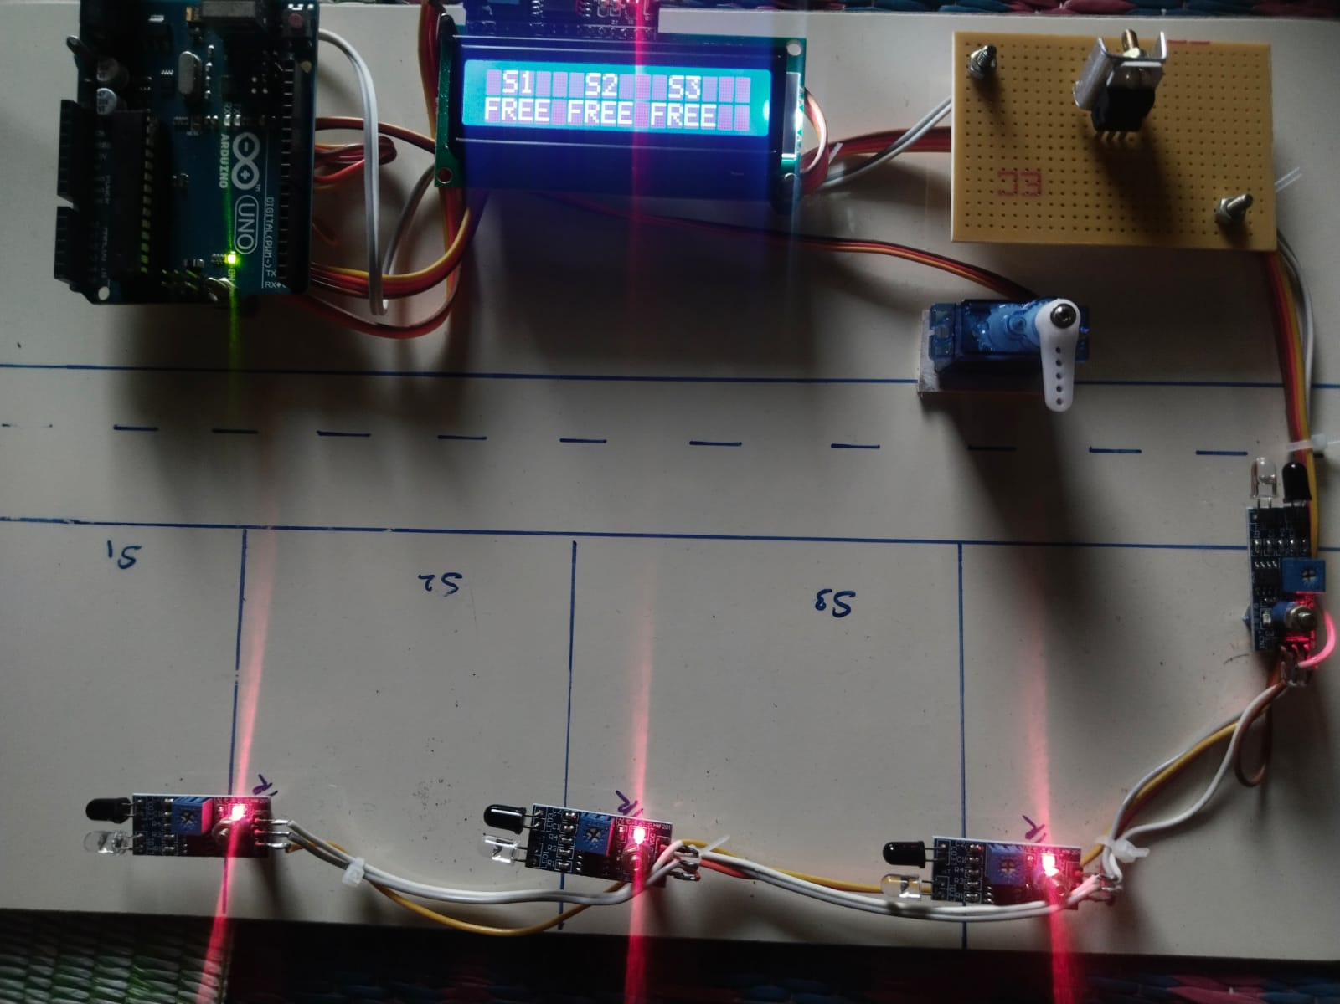

Fig 6.1

6.2 Parking a vehicle

* The below diagram shows the status of the parking zone when a single vehicle is parked in the parking zone. Once when the user enters the parking detect sensor he would receive a parking slot number on his mobile application which he is supposed to park his vehicle. Upon parking the vehicle in the respective slot and IR sensor successfully detecting the vehicle it would show a notification on the app the start time of the vehicle and the slot number in which the vehicle is parked and it would be similarly updated on the 16*2 display

When one parking spot is filled

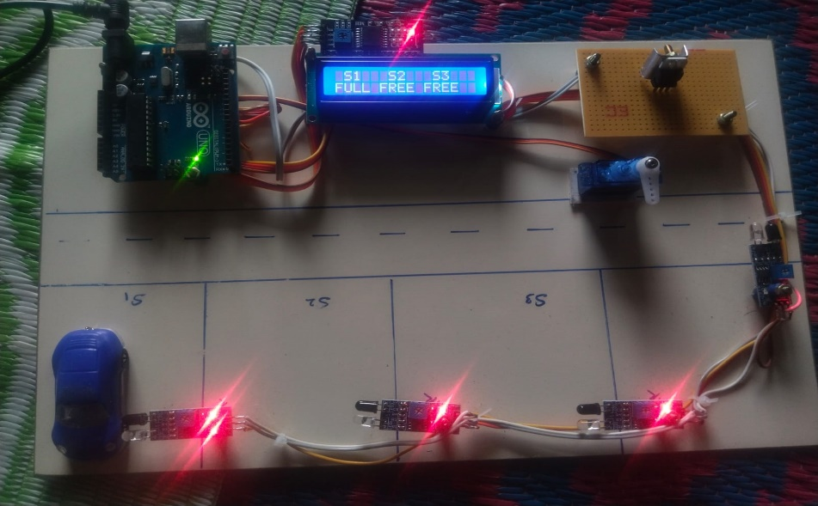

Fig 6.2

* In a situation when all the slots are filled and a new vehicle comes near to the vehicle detecting sensor ,the below message is popped on the user screen which displays that there are no parking slots available and the user can move his parking vehicle away from the parking zone .

No available parking slots

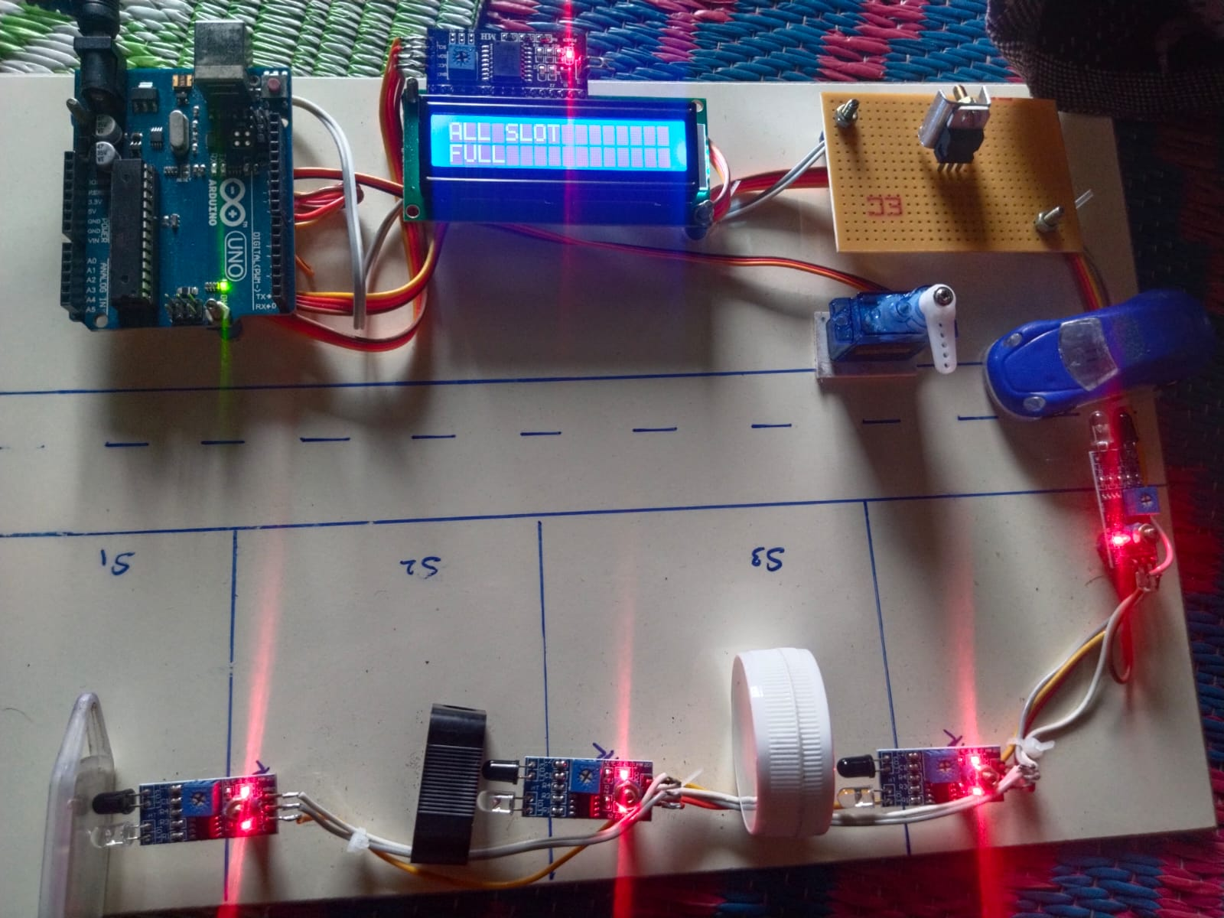

Fig 6.3

CHAPTER 7

7.1 CONCLUSION

The concept of Smart Cities has always been a dream for humanity. Since the pastcouple of years ago large advancements have been made in making smart cities a reality.The growth of Internet of Things and Cloud technologies have given rise to new possibilities in terms of smart cities. Smart parking facilities and traffic management systems have always been at the core of constructing smart cities. The system that we propose provides real time information regarding availability of parking slots in a parking area. Users from remote locations could book a parking slot for them by the use of our mobile application.The efforts made in this project are intended to improve the parking facilities of a city and thereby aiming to enhance the quality of life of its people

7.2 Future work

* The future of smart parking systems is expected to be significantly influenced by the arrival of automated vehicles (AVs)
* Several cities around the world are already beginning to trial self -parking
* vehicles specialized AV parking lots and robotics parking valets.
* This project can be enhanced for tracking vehicle speed on the roads.
* Developing a smart parking solution within a city solves pollution problem
* Addition of Machine learning to store various other information of the vehicle

REFERENCES

[1] Abdul Ahad, Zishan Raza Khan, Syed Aqeel Ahmad,“Intelligent Parking System” Scientific Research Publishing, Vol.4,No.2, pp. 160-167, May 2016.

[2] Dr Y Raghavender Rao,” Automatic Smart Parking System using Internet of Things

(IOT)” International Journal of Engineering Technology Science and Research,Vol.4,No.5,pp.225-258,May 2017

[3] Suprit Atul Gandhi, Hasan Mohammad Shahid,” Smart Parking System”

[4] Asian Journal of Convergence in Technology, Vol.4,No.1,May 2017Benson, J.P., T. O'Donovan, P. O'Sullivan, U. Roedig and C. Sreenan et al.,”Car park management using wireless sensor networks”, Proceedings of the 31st Conference on Local Computer Networks, Tampa, FL., USA., pp: 588-595 November 2006.

[5] Geng Y. and Cassandras C. G, “A new smart parking system based on optimal resource allocation and reservations,” in Proc. IEEE Conf. Intell. Transp. Syst. pp. 979–984, July 2011.

[6] M. M. Rashid, A. Musa, M. Ataur Rahman, and N. Farahana, A. Farhana, “Automatic Parking Management System and Parking Fee Collection Based on

Number Plate Recognition.”, International Journal of Machine Learning and Computing, Vol. 2, No. 2, April 2012 Published 2014.

[7] Arduino.cc. (2018). Arduino - ArduinoMega2560. , retrieved date: 21Oct.2018,

Online at :https://www.arduino.cc/en/Guide/ArduinoMega2560